# REPORT ON BEST PLATFORM TO HOST SSCM SYSTEM

## Introduction

We are looking into where we would host the system for deployment. During the development phase, different solutions are in use.

## Metrics considered

### Earth Engine integration

The system uses google earth engine to process queries. The platform in question should be easy to integrate with google earth engine.

Earth Engine is integrated with Google Cloud Platform. Specifically, the [Earth Engine REST API](https://developers.google.com/earth-engine/reference) is a [Google Cloud API](https://cloud.google.com/apis/docs/overview). When you make calls to a Cloud API, you make calls through a [Cloud Project](https://cloud.google.com/docs/overview#projects). This enables usage, storage and permissions to be configured and monitored at the project level and more easily managed for groups or collaborators.

### Pricing

For development, which is the primary use for the platform, as well as for long term use (which adds the dimension of increased number of users).

B instances stand for backend instances.

F instances are frontend instances.

React is a front-end library. This means we will likely use front-end instances.

Of all the instances and regions, Mumbai was the closest to Kenya geographically although perhaps technically servers in London might be the closest (least hops network-wise).

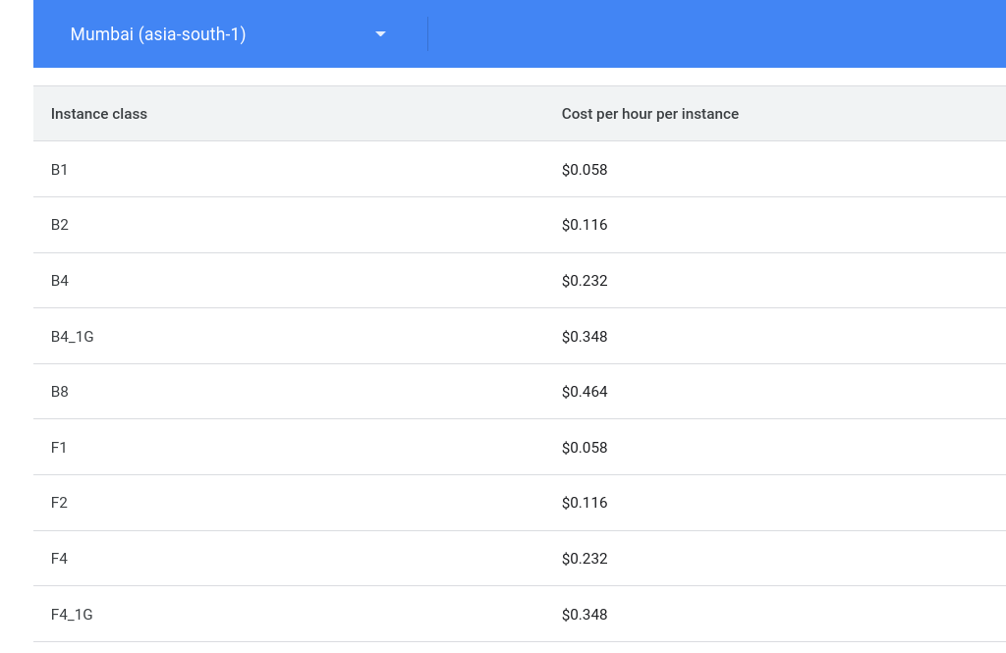

### Locale

The system is for use within Kenya. As such, global distribution is not a requirement.

Best case would be a platform with servers within the country. If no such exists, the closer to home the better.

### Long-term considerations

With time, the platform should handle scaling well. Increased number of users as well as increase in the workload / queries.

### Support

There is a time constraint. It should be very easy and fast to set up and deploy. Better documented and popular sites that have support are the target.

Google has an API reference page for connecting Earth Engine to Google Cloud platform specifically.

### Other Considerations

By choosing to use google earth engine in place of other solutions, we locked ourselves into a corner. Earth engine is inherently a google cloud platform product. The path of least resistance is to use other google products as opposed to solutions from other vendors. This way all the billing and use is under one google account (which we already have since we had to make one to use earth engine).

## Candidates

### Amazon Web Services (AWS)

Has Earth on AWS.

AWS Cloud Credits for Research are available for anyone to conduct research using Earth Observation data on AWS. Students, educators, and researchers are key drivers of technological innovation and we want to support new advances in the field.

### Microsoft Azure

### Google Cloud

### Alibaba Cloud

### IBM Cloud

### Oracle

### Salesforce

### SAP

### Rackspace Cloud

### VMWare

### 

## Proposed candidate

Google Cloud Platform

## Database

The database in use is mongodb. Mongodb, the company offers database hosting services. Rates below:

